**WEEK 11 TUTORIAL**



**SUBMITTED BY: SUBMITTED TO:**

**SHUBHAM GARG MR. MUKESH SARASWAT**

**9919103057**

**BATCH:F2**

***ARRAY***

**# Write a C Program to delete an element from an array at specific position.**

#include<stdio.h>

void main()

{

int a[10];

int i,j,pos;

printf("Enter the Array's Elements\n");

for(i=0;i<10;i++)

scanf("%d",&a[i]);

printf("\nEnter the Posititon from where you want to delete the Element\n");

scanf("%d",&pos);

if(pos>=1 && pos<=10)

{

for(j=pos-1;j<9;j++)

{

a[j]=a[j+1];

}

}

else

printf("Position is Invalid");

printf("\nAfter Deletion\n");

for(i=0;i<9;i++)

printf("\n%d",a[i]);

}

**OUTPUT :**

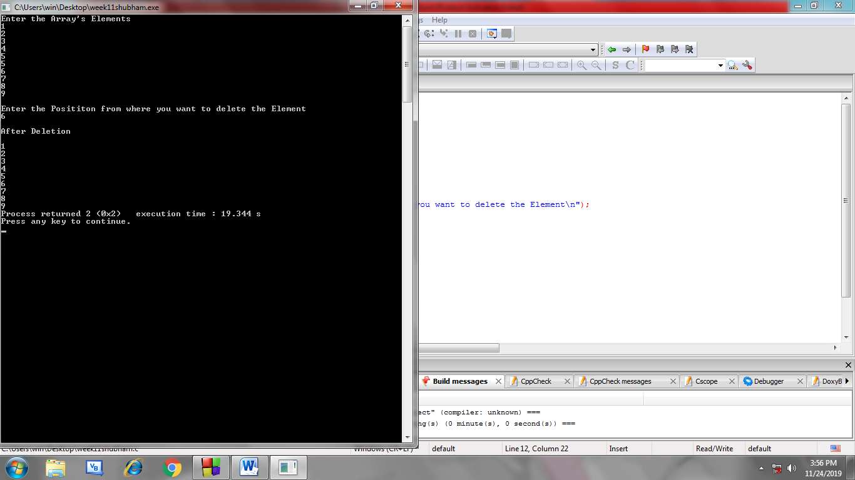

**# Write a C Program to count frequency of each element in an array.**

#include<stdio.h>

void main()

{

int a[10],i,times,freq[10],j;

printf("Enter Array's Elements");

for(i=0;i<10;i++)

{

scanf("%d",&a[i]);

freq[i]=-1;

}

for(i=0;i<10;i++)

{

times=1;

for(j=i+1;j<10;j++)

{

if(a[i]==a[j])

{

times++;

freq[j]=0;

}

}

if(freq[i]!=0)

freq[i]=times;

}

printf("\nFrequency of all the Elements are;\n");

for(i=0;i<10;i++)

{

if(freq[i]!=0)

printf("%d occurs %d times\n",a[i],freq[i]);

}

}

**OUTPUT:**

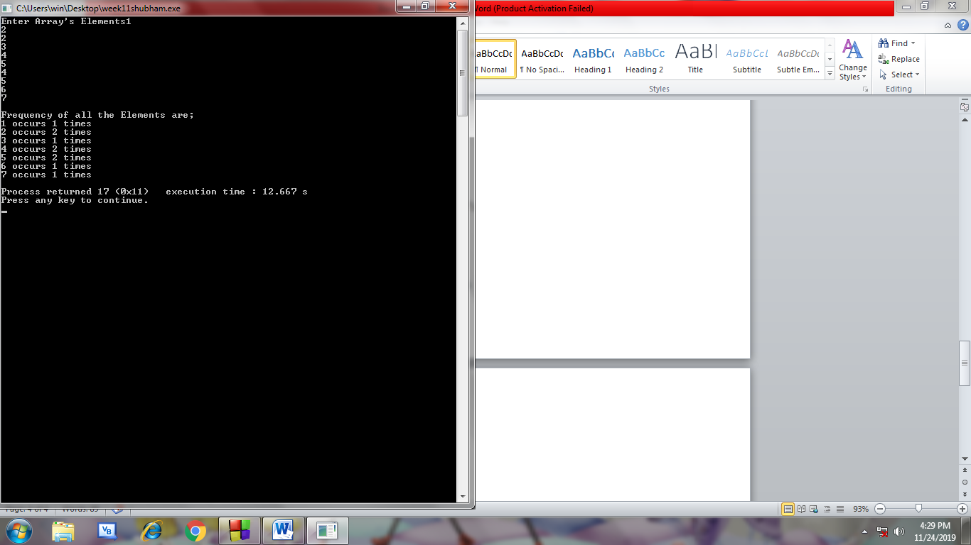

***STRING***

**# Write a C Program to find length of a string.**

#include<stdio.h>

void main()

{

char str[100];

int i=0;

printf("Enter the String\n");

gets(str);

while(str[i]!='\0')

{

i++;

}

printf("The Length of the Strin is %d ",i+1);

}

**OUTPUT:**

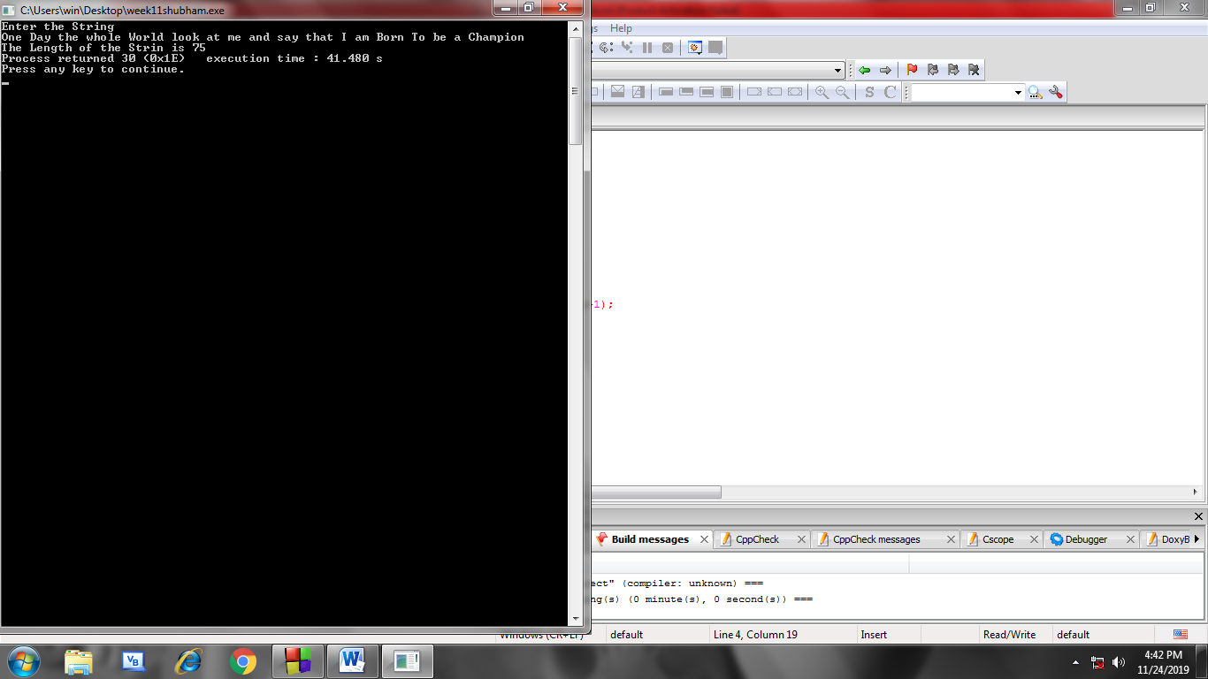

**# Write a C program to check whether a character is Digit or not.**

#include<stdio.h>

void main()

{

char ch;

printf("Enter the Character\n");

scanf("&c",&ch);

int i=(int)ch;

if(i>=48 || i<=57)

printf("The Character entered is a DIGIT");

else

printf("The Character entered is NOT a digit");

}

**OUTPUT :**

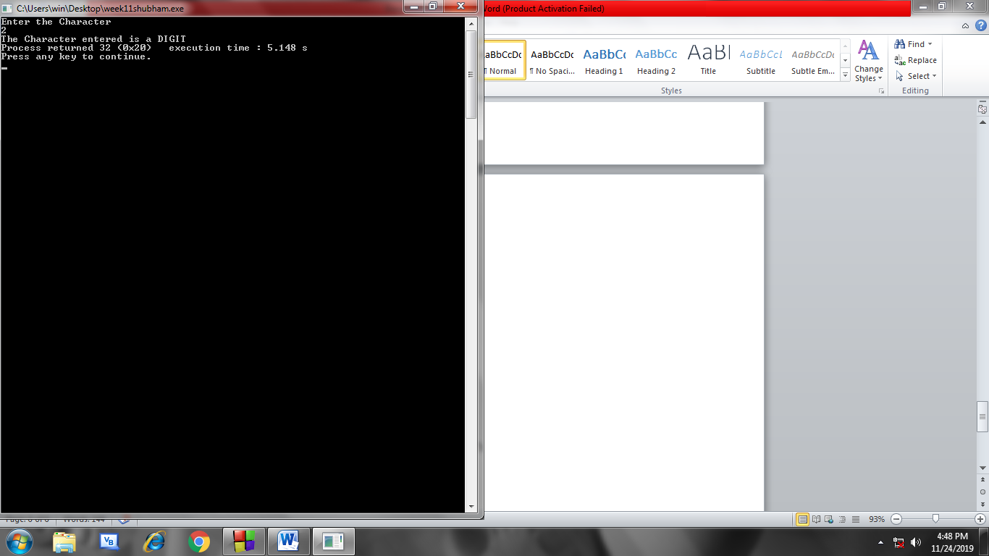

**MATRIX**

**# Write a C program to perform Scalar matrix Multiplication.**

#include<stdio.h>

void main()

{

int a[4][4];

int i,j,n;

printf("Scalar Matrix Multiplication\n");

printf("Enter Matrix elements\n");

for(i=0;i<4;i++)

{

for(j=0;j<4;j++)

{

scanf("%d",&a[i][j]);

}

}

printf("Enter Number to be Multiplied\n");

scanf("%d",&n);

printf("After Multiplication\n");

for(i=0;i<4;i++)

{

for(j=0;j<4;j++)

{

printf("%d ",n*a[i][j]);

}

printf("\n");

}

}

**OUTPUT:**

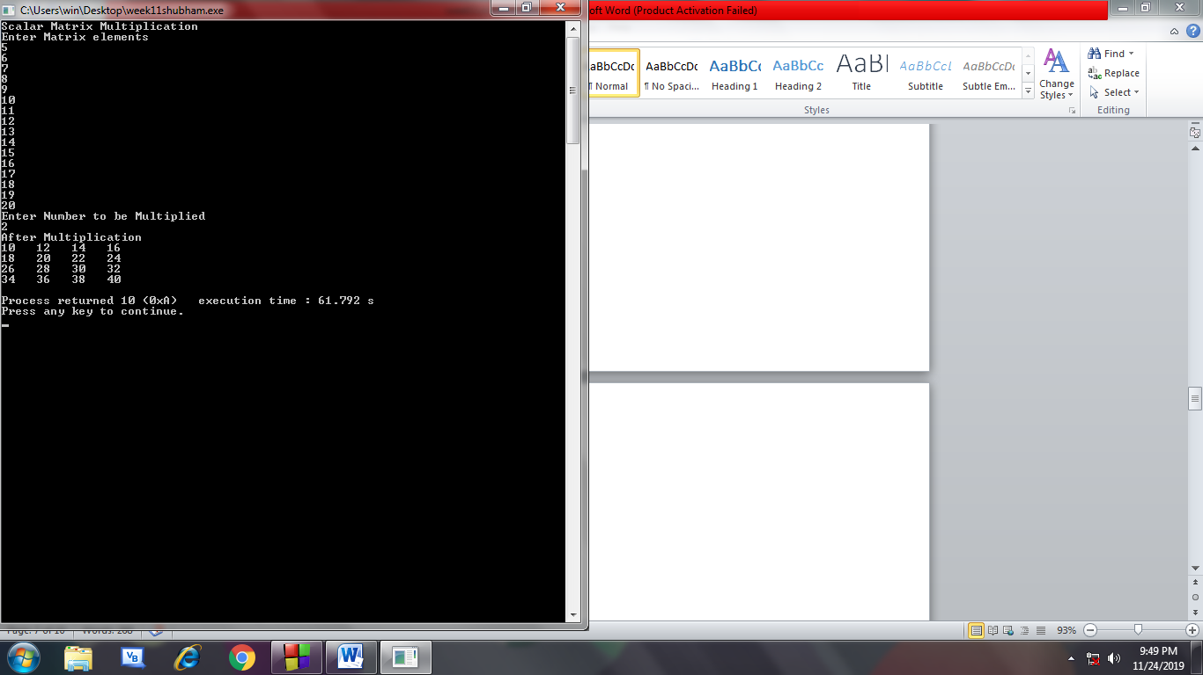

**# Write a C program to multiply two matrices.**

#include<stdio.h>

void main()

{

int a[10][10],b[10][10],c[10][10];

int r1,c1,r2,c2,i,j,k;

printf("Matrix Multiplication\n");

printf("Enter number of rows and columns of Matrix1\n ");

scanf("%d%d",&r1,&c1);

printf("Enter number of rows and columns of Matrix2\n ");

scanf("%d%d",&r2,&c2);

if(c1==r2)

{

printf("Enter Matrix1 elements");

for(i=0;i<r1;i++)

{

for(j=0;j<c1;j++)

{

scanf("%d",&a[i][j]);

}

}

printf("Enter Matrix2 elements");

for(i=0;i<r2;i++)

{

for(j=0;j<c2;j++)

{

scanf("%d",&b[i][j]);

}

}

for(i=0;i<c1;i++)

{

for(j=0;j<r2;j++)

{

c[i][j]=0;

for(k=0;k<r2;k++)

{

c[i][j]=c[i][j] +a[i][k]*b[k][j];

}

}

}

for(i=0;i<r1;i++)

{

for(j=0;j<c2;j++)

{

printf(" %d ",c[i][j]);

}

printf("\n");

}

}

else

{

printf("Matrix Multiplication is not possible ");

}

}

**OUTPUT:**

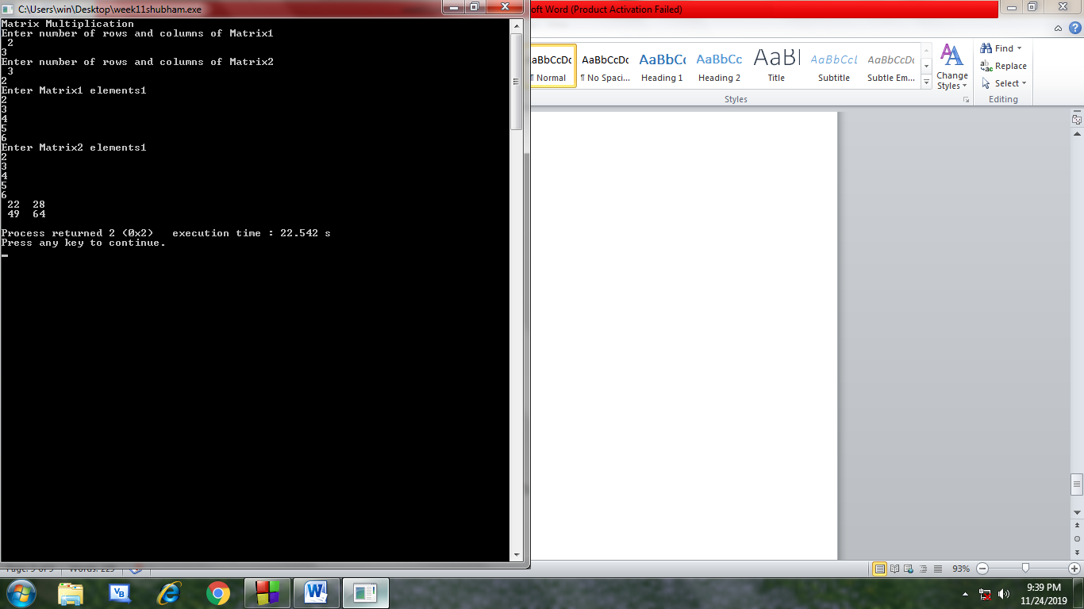

**-X-X-X-X-X-X-X-X-X-X-X-**